Data cleaning and transformation
- Altered table to update data type of date and time
- Update booking id and customer id and remove double quotes from their ids
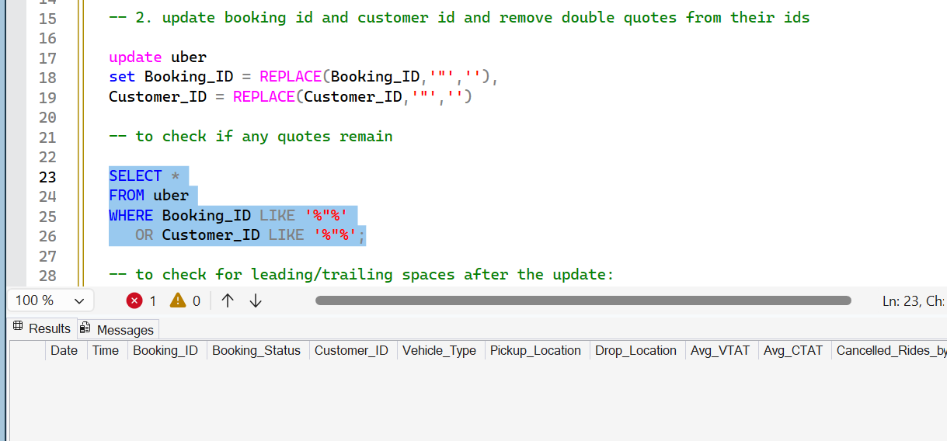
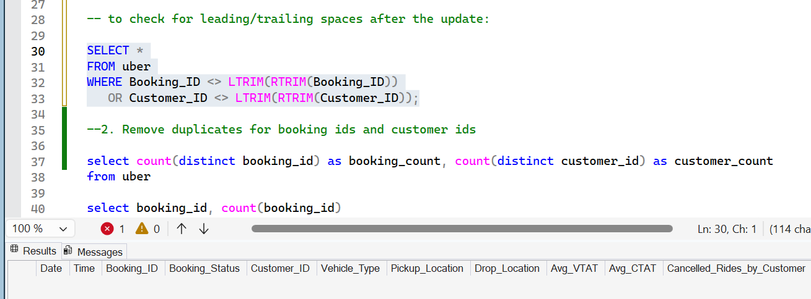
- Duplicate records - We have total 150000 records, out of which 148767 distinct booking IDs and 148788 distinct customer IDs, that means some of the booking IDs have 2 or more bookings for the same booking ID
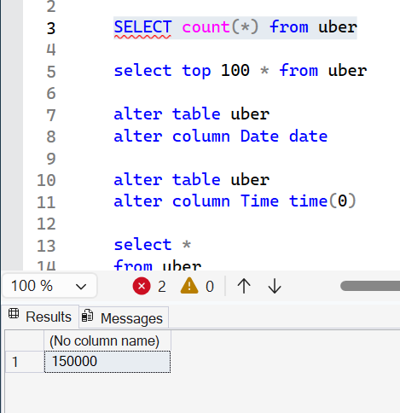
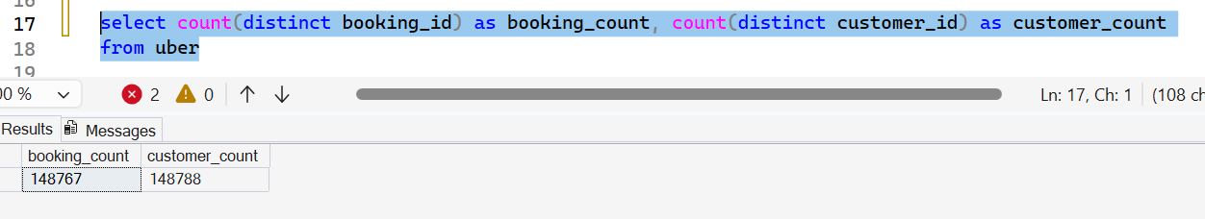
There are total 1224 booking ids who have more than 1 bookings for same booking id
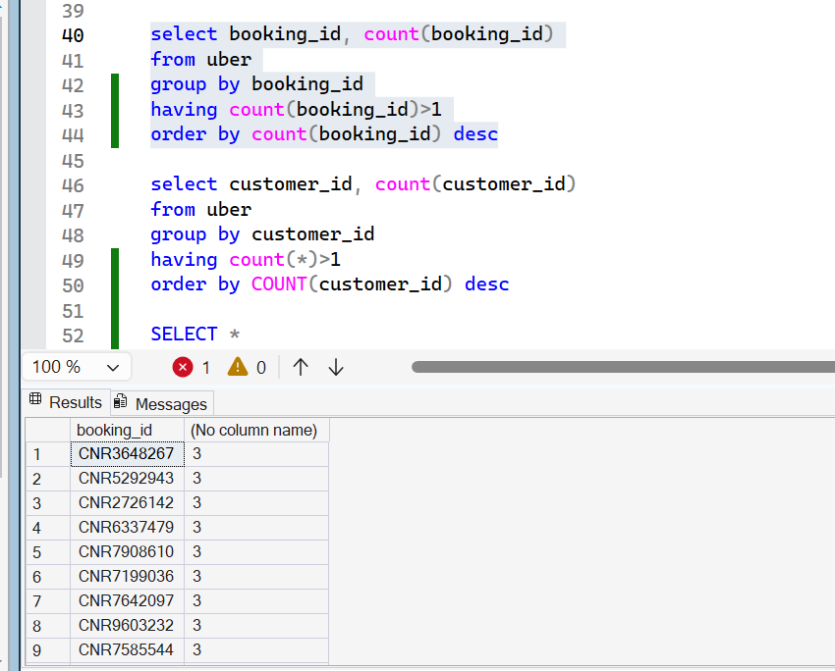
Total booking count – 148767, more than 1 – 1224 (148767+1224 = 149991), 9 booking IDs have more than 2 count (total – 1224+9 = 1233)
1206 customer ids more than 1 count –
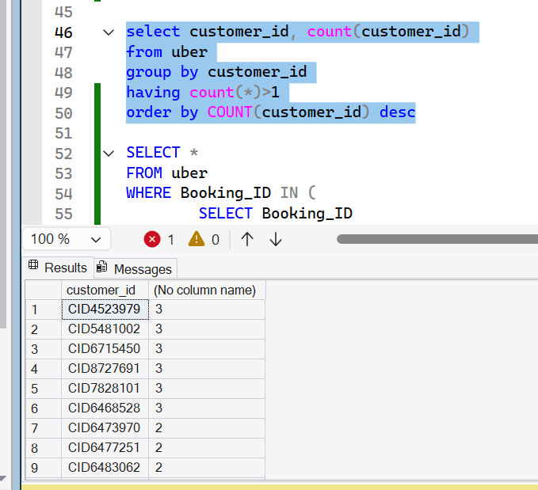
Total – 148788, duplicated – 1206, 148788+1206 = 149994, 6 ids have more than 2 customer ids, and hence the total (1206+6 = 1212)
Now we have to check the ids with more than 1 bookings for both customers and bookings ids, as at one time there can be only one booking id and customer id, as these 2 are unique identifier for each ride booking and for customers
There are no duplicate rows.
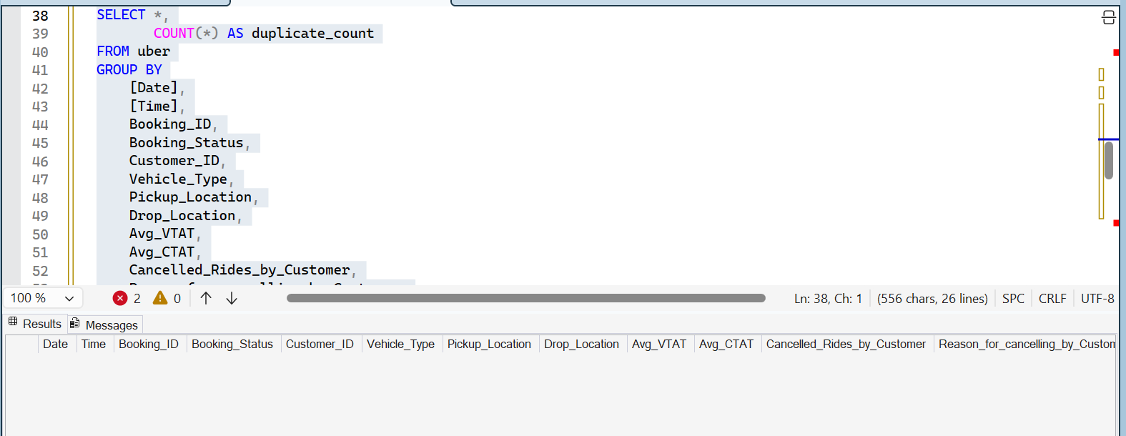
Since, in description, it is mentioned, booking id and customer id are unique, but there are multiple records against same ids.
- Booking_ID was expected to be unique at the ride level. Data profiling identified 1,224 Booking_IDs occurring multiple times across different customers and dates. Due to the synthetic nature of the dataset, Booking_ID was treated as an informational attribute rather than a unique identifier. A surrogate key (Ride_Key) will be used in the fact table.
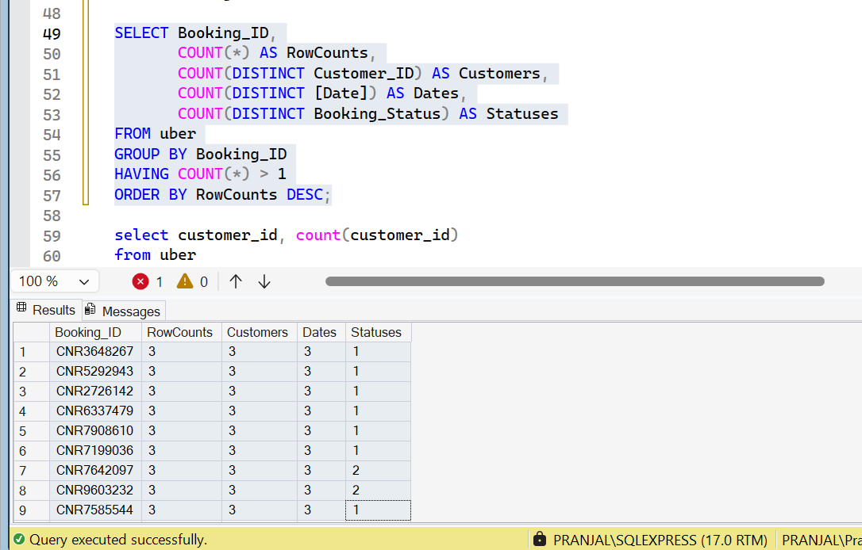
- Check for NULLs
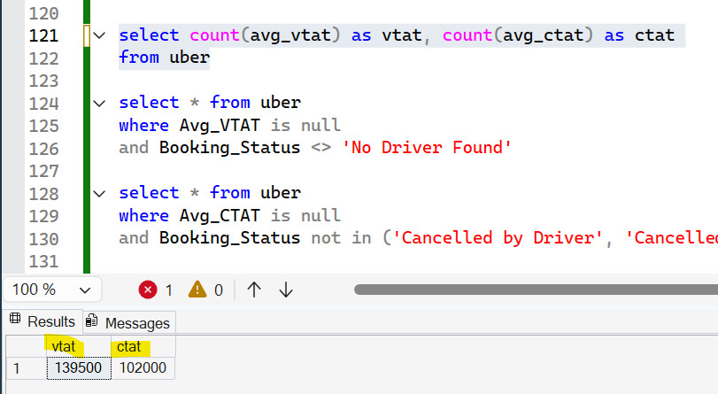
Avg_VTAT is null for all the booking types = ‘No Driver Found’
For all avg_VTAT as null, avg_CTAT is also null as no rides booked for the same
Total – 10,500 nulls
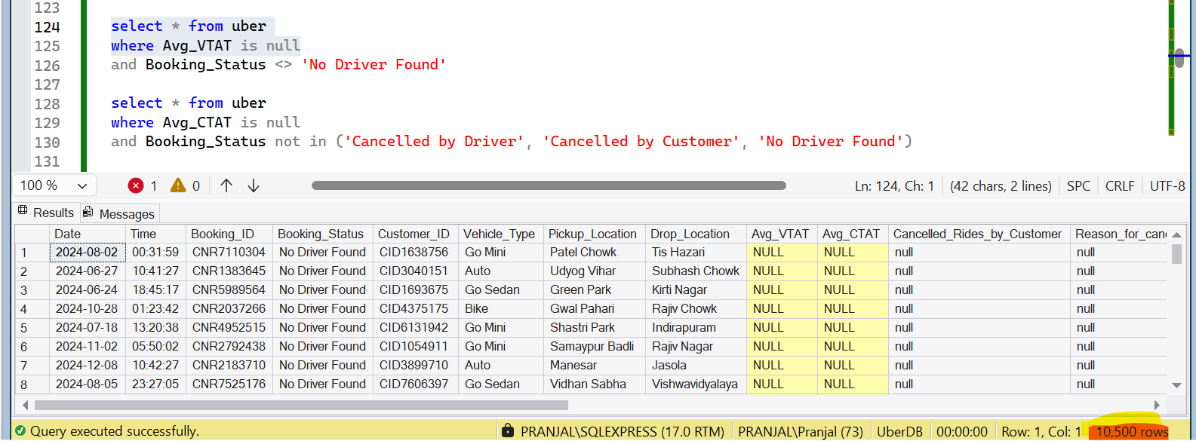
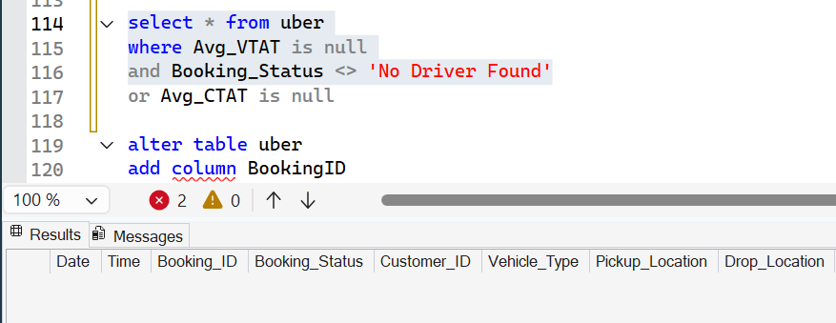
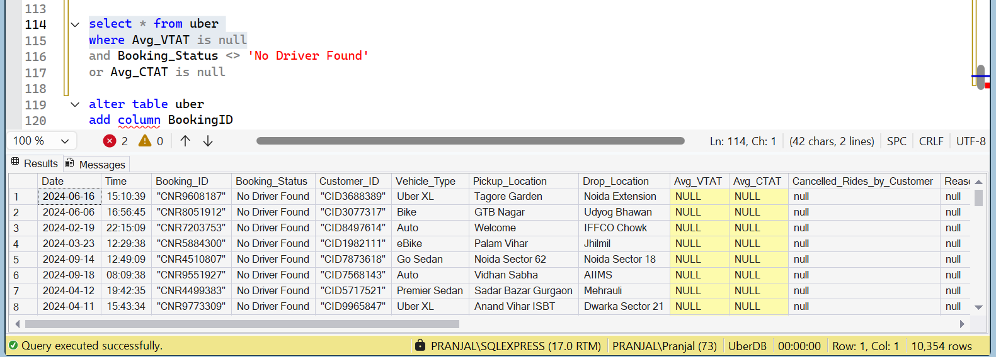
For avg_CTAT to be null –
These 3 reasons are there - ('Cancelled by Driver', 'Cancelled by Customer', 'No Driver Found')
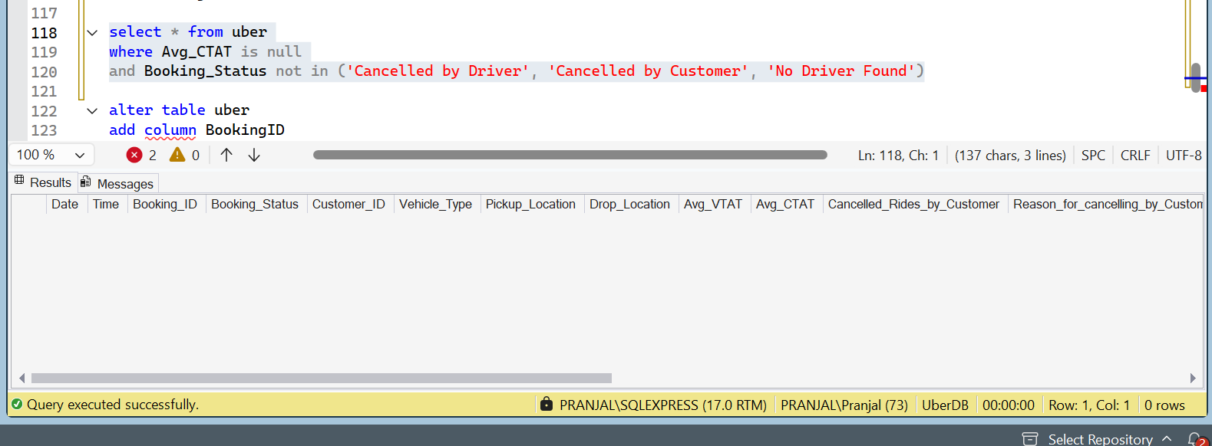
Total 48,000 - nulls
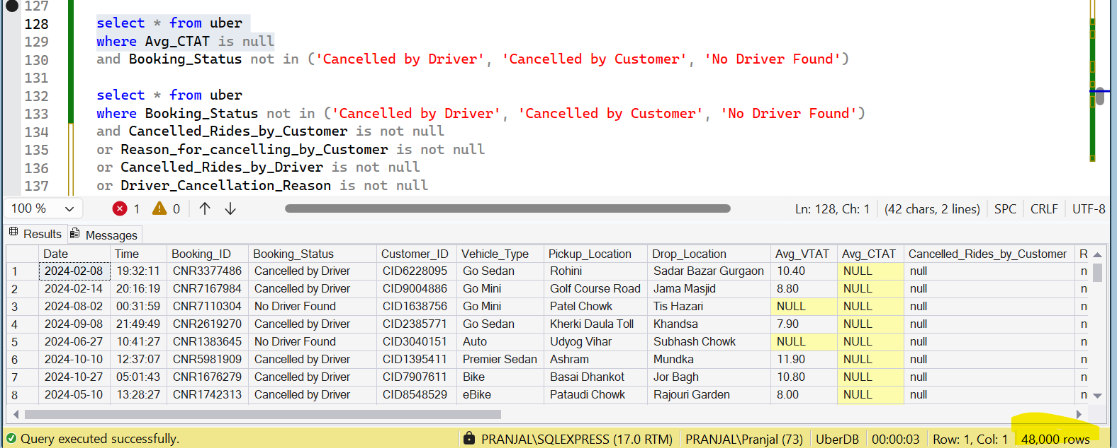
So no NULL issue for these 2 columns, as it justifies the null values.
Data is fine as no null values for unusual data
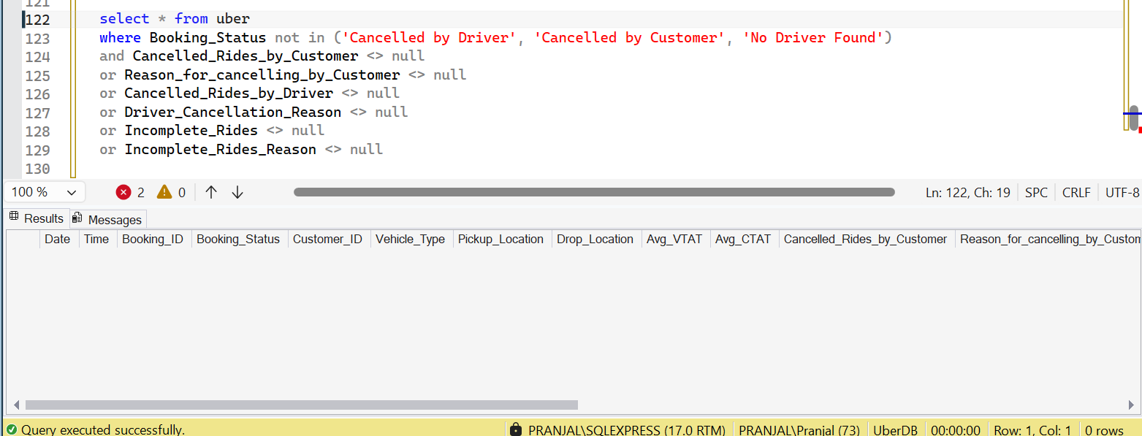

- Types of booking status, vehicle type, reasons for cancellation, payment method
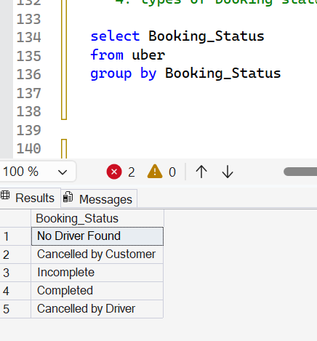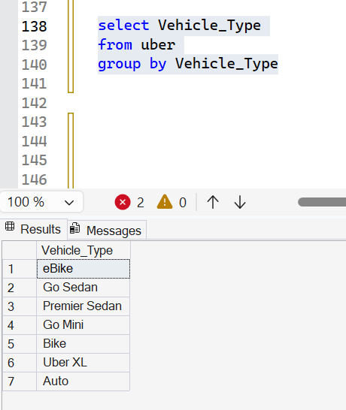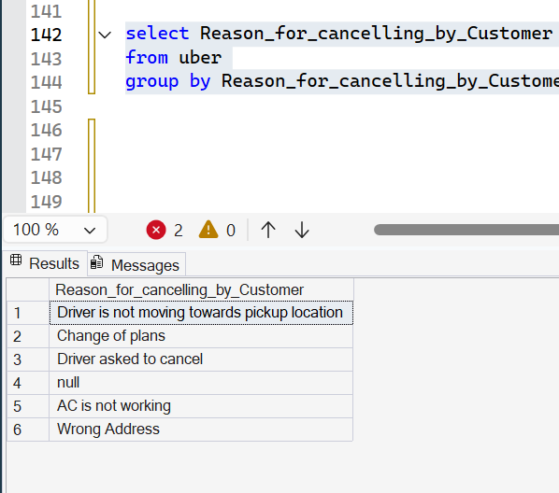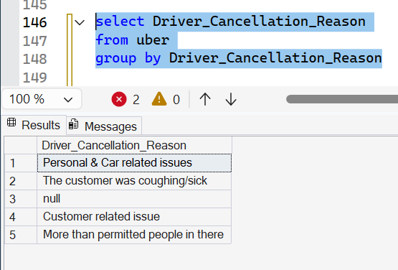
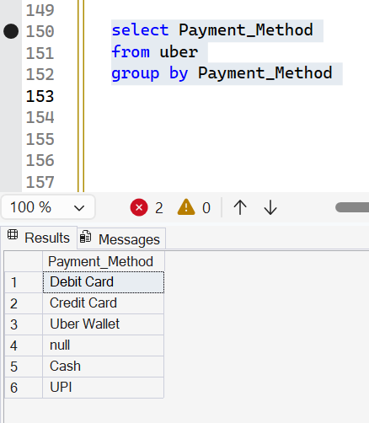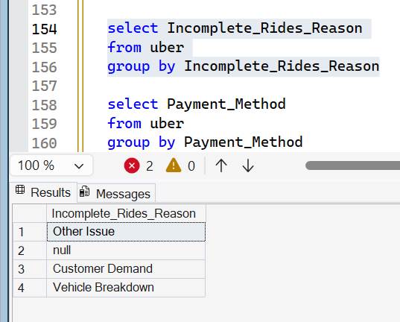
These queries prove that there’s no spelling mistake or inconsistent words written
For cancelled rides by customer or driver, there are only null and 1 values
For incomplete rides – we have 3 values – null,1 and blank
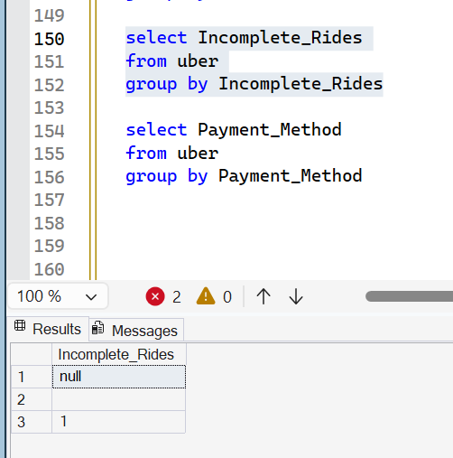
- Check for incomplete rides – blank records
there is only 1 ride with blank value, for which booking status is ‘no driver found’, so it is okay to enter ‘null’ for incomplete ride as there will be no incomplete rides for this type of booking status
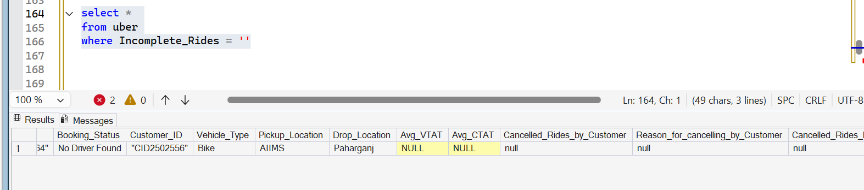
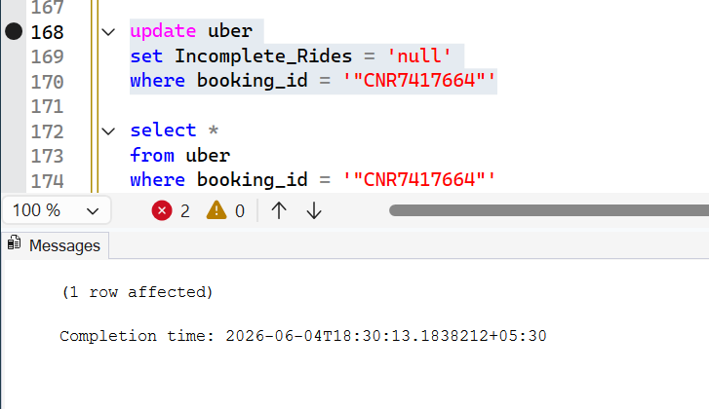
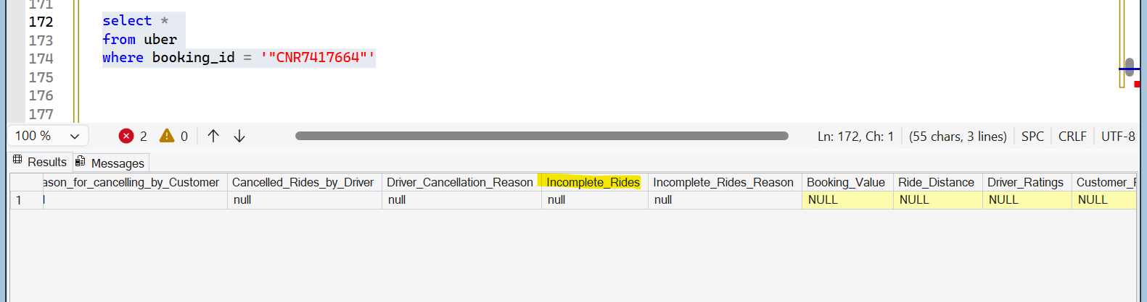
- Check date range
select MAX(date) as max_date, MIN(date) as min_date
from uber
- Ratings should range between 1 to 5
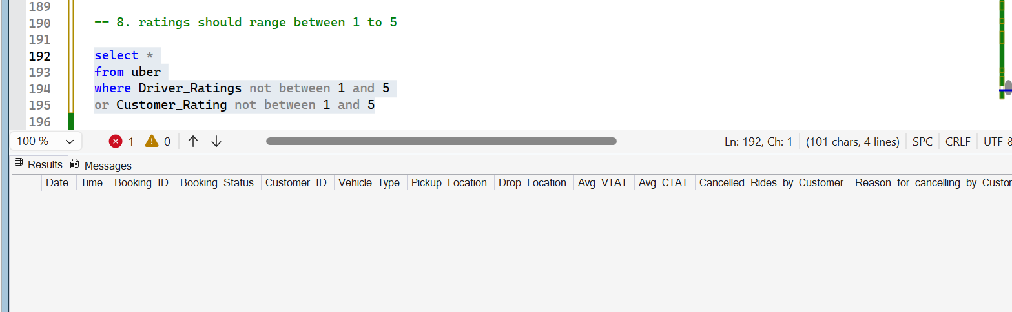
- Validate distance
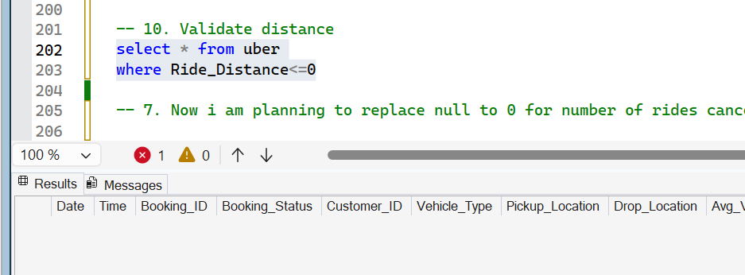
- Check outliers –
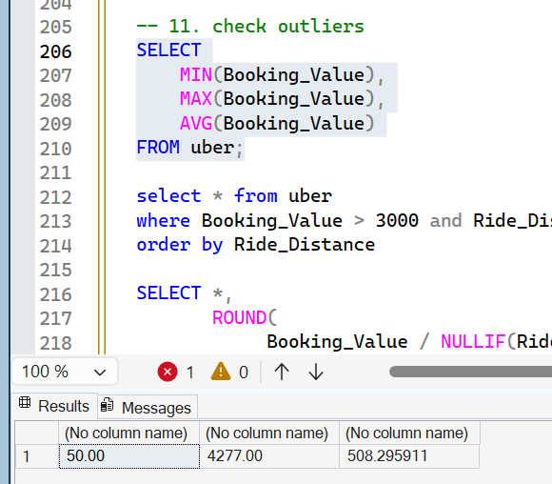
Max booking value is 4277. To find outliers, we will find costPerKM, to check KM pricing.
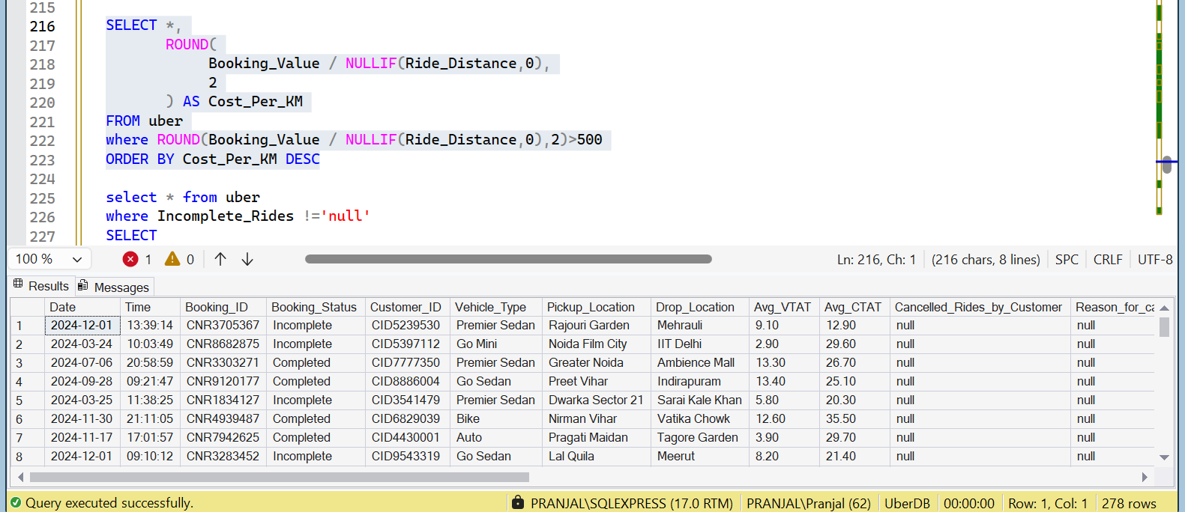
Data profiling identified 278 records with a fare-per-kilometer ratio above ₹500.
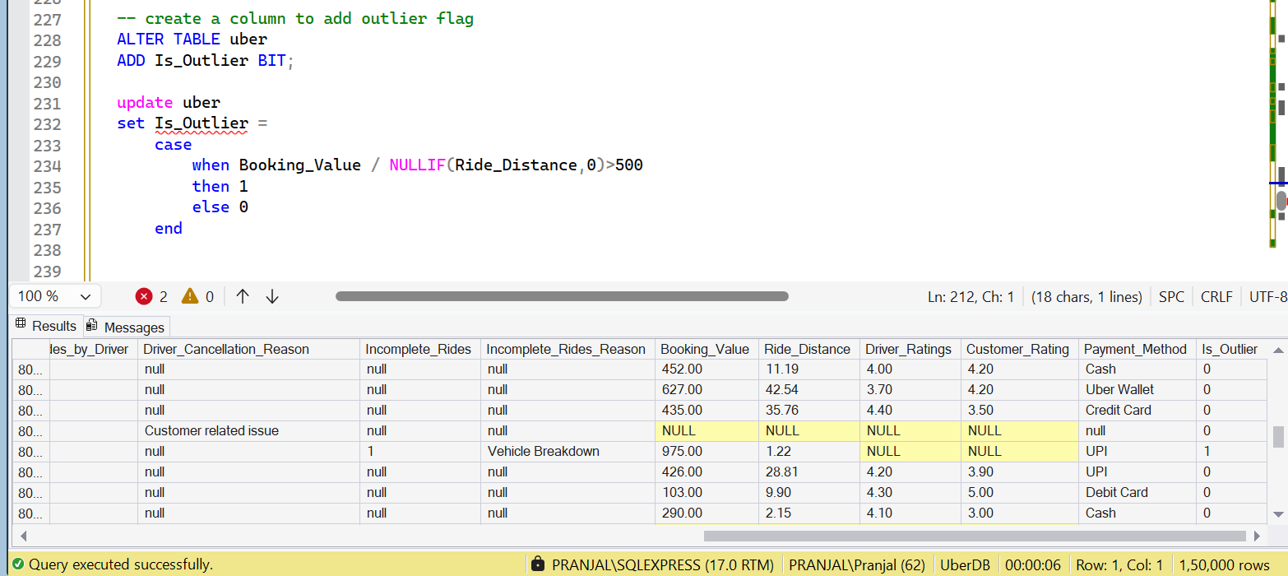
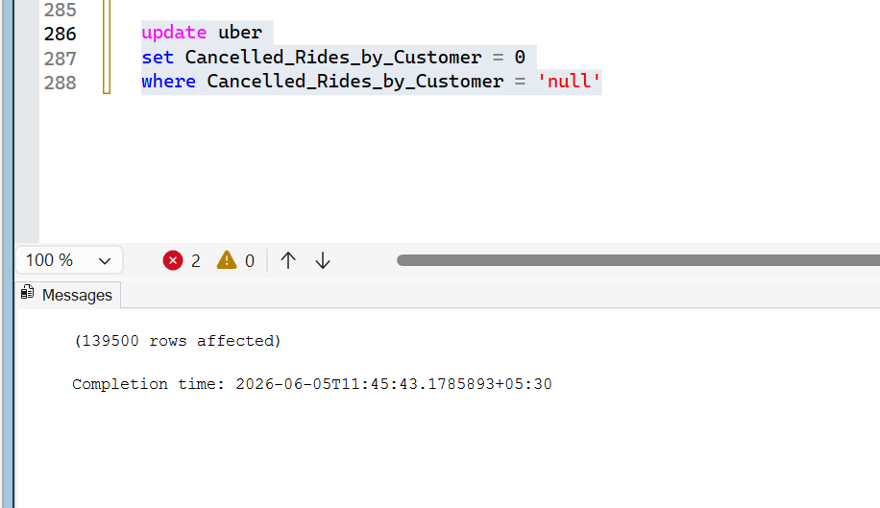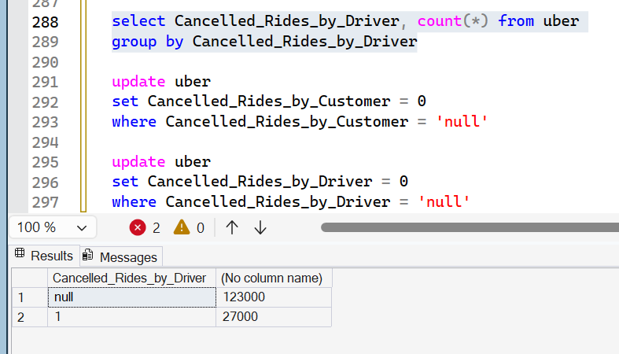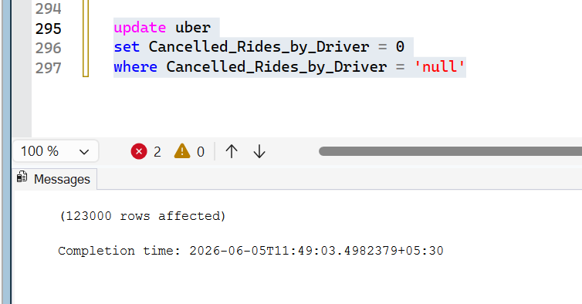
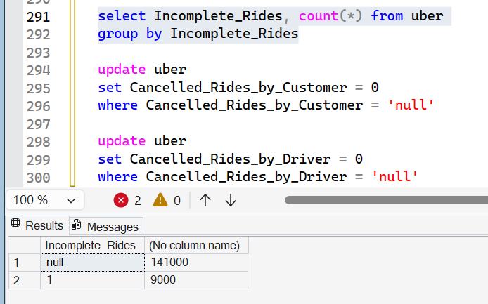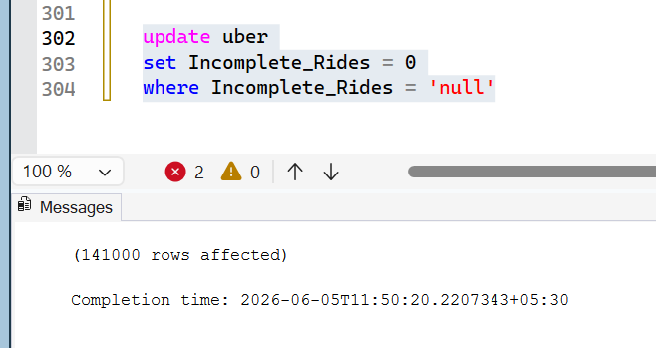
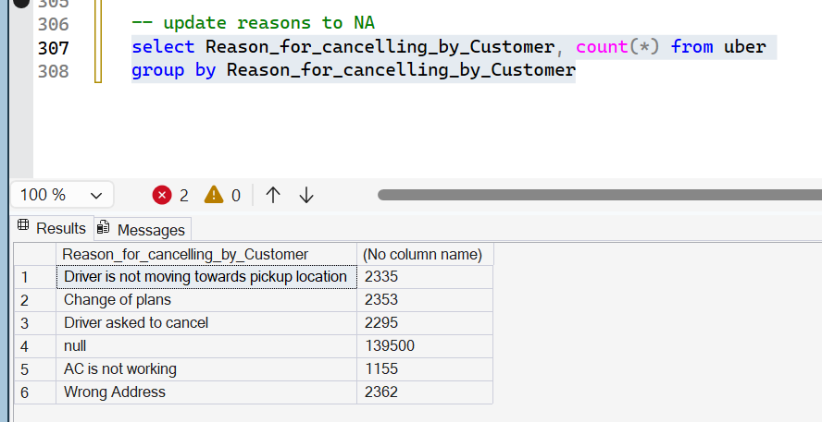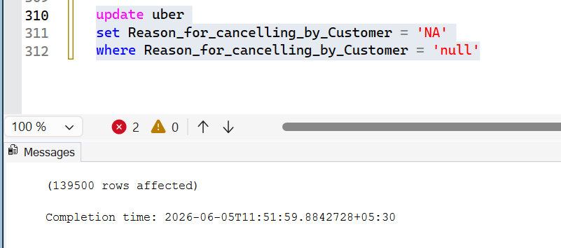
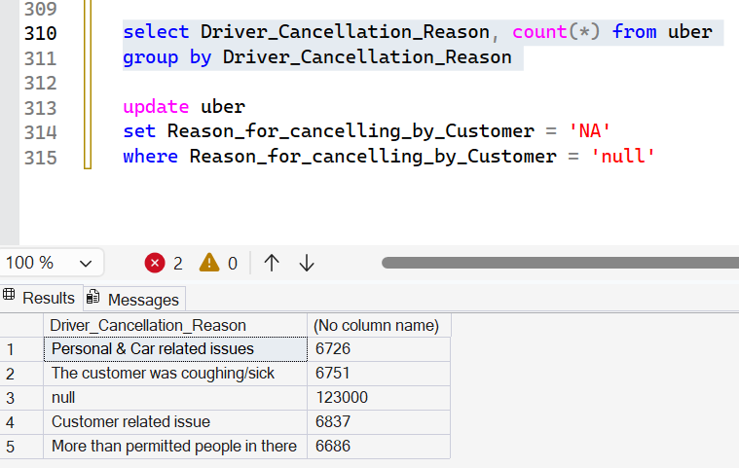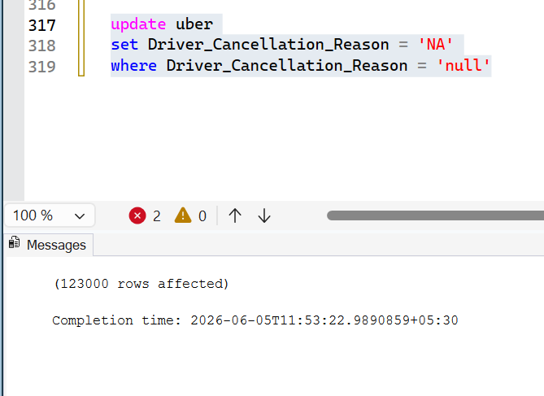
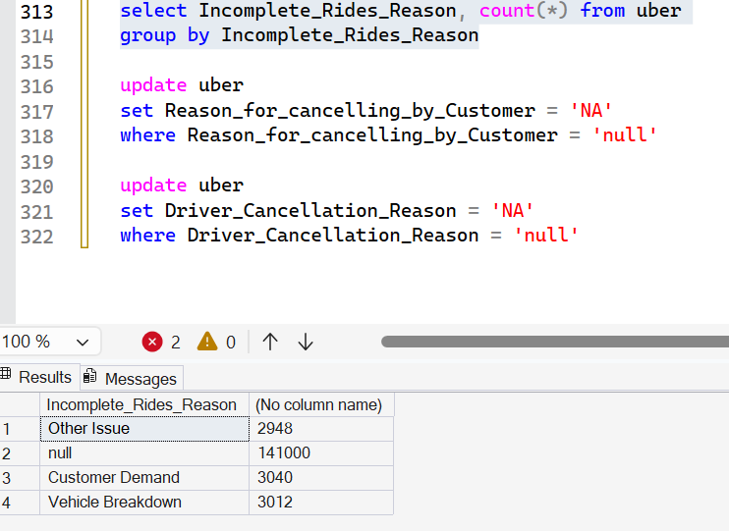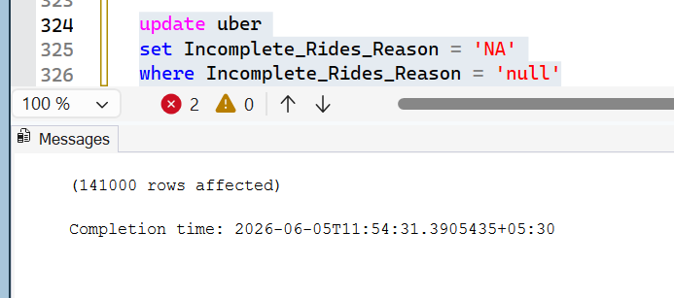
- Update the data types of rides canceled or incomplete number –
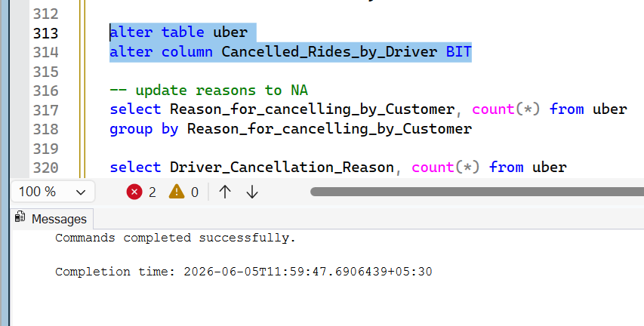
SQL query attached separately ------
Create Star schema
Grain
One row in Fact_Rides represents one ride booking transaction.
Dimensions
- Date → ride trends over time
- Time → peak-hour analysis
- Vehicle → ride type analysis
- Status → cancellation analysis
- Payment → payment preference analysis
- Location → pickup/drop hotspot analysis
Facts
- Revenue (Booking_Value)
- Distance (Ride_Distance)
- Ratings
- VTAT/CTAT metrics
- Cancellation reasons and rides
Design Decisions
- Used a surrogate key (Ride_Key) because Booking_ID was not unique in the source data. Act as a unique identifier for all data
- Kept cancellation reasons in the fact table due to low cardinality and limited analytical value as standalone dimensions.
- Reused Dim_Location twice (pickup and drop) as a role-playing dimension, which is a classic dimensional modeling technique.
Cancellation reasons had very low cardinality and were not expected to be major slicing dimensions in reporting. To keep the schema simple and avoid over-modeling, I retained them as descriptive attributes in the fact table while creating dimensions only for high-value analytical entities such as Date, Time, Location, Vehicle, Status, and Payment.
Data Quality Issue | Action
Duplicate Booking IDs | Retained; used surrogate key in fact table
Quotes in IDs | Removed
Null cancellation reasons for completed rides | Retained as expected
Extreme cost-per-km values | Marked as Outliers
Source data | Preserved in raw staging table

SQL query script is present separately.

